**Data Analyst**

**Exploring Weather Trends**

**Overview**

In this project I will analyze and compare the average temperature of my local city to the global average temperature.

**Steps:**

* Exploring the database which provided by Udacity and querying the global database.
* Selecting city and country from the database through “city_list” database.
* Extracting the CSV files for the global and the city databases.

**Tools used:**

1. SQL statements used to extract the data from database.

**SELECT * FROM global_data;**

**SELECT * FROM city_data WHERE city = 'Riyadh' AND country = 'Saudi Arabia';**

1. Python and **Jupyter to calculate** the moving average of global and city temperatures. Besides to plot the line chart.

**Moving Average:**

To smooth the data and to observe trends in the temperature. I’ve done 10 year Moving Average to get smooth line chart.

The below line chart compares between Riyadh City average temperature and the global average temperature.

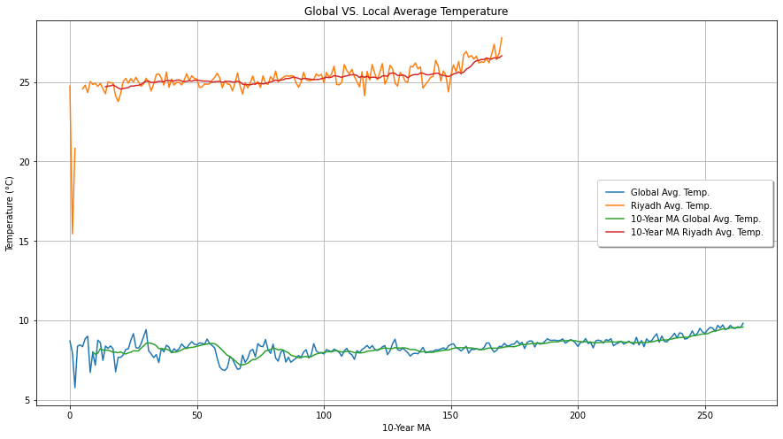

**Observations:**

1. The global temperature has been in the range of 8 °C and 10 °C in the time period 1750-2010. Whereas Riyadh has been hotter, in the range of 24.5 °C and 25.5 °C at the same time period.
2. The average difference seems to be 2 °C consistently, throughout the time period 1750 to 1975. After that it increased slightly (0.5 °C), as Riyadh has been getting warmer quicker than the earth.
3. The global has logged an extreme outlier average temperature 5.75 in 1752.
4. Overall trend of Riyadh’s average shows that Riyadh city is much hotter than the global average. This difference has been consistent overtime.
5. Overall trend shows the global is consistently getting hotter after 1973.

**Considerations:**

* X-axis: Years
* Y-axis: Temperature (°C)
* Legends are plotted in the chart
* Different colors of lines for global and city temperatures.